Superannuation Guarantee Contribution (SGC) – Annual Authority
Engagement to provide Superannuation Guarantee Services
This authority confirms the engagement with the ‘Agent’ [your name and BAS Agent Number] to prepare and lodge Superannuation Contribution payments as required by the Superannuation Guarantee (Administration) Act 1992 (SGAA) as required to provide the services outlined in the letter of engagement ‘the Agreement’ over the course of the year between 1 July and 30 June. The services outlined in the Agreement form part of this declaration.

Agent Acknowledgement and Consent
This declaration will be renewed at least every 12 months.
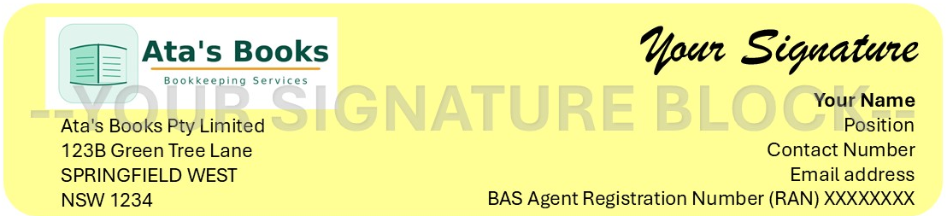
Client Declaration and Authorisation
By signing this declaration, I the undersigned:
- Authorise the Agent from this date to prepare and lodge Superannuation Contribution payments the entities.
- Confirm I am authorised to make this declaration for the entities I am signing the Agreement on behalf of.
- Accept the responsibility of providing staff salaries and worked hours by the appropriate pay run date to the Agent as my authorised BAS agent.
- Declare that wages are paid in line with the appropriate payroll awards and Fairwork guidelines.
- Declare the appropriate PAYG amounts will be withheld from each pay along with the statutory rate of Superannuation.
- Indemnify the Agent against any claims, losses, liabilities, or expenses (including legal fees) that arise as a result of incorrect, incomplete, or misleading information provided by the client, or from the client’s failure to meet their statutory obligations in relation to payroll and superannuation.

This engagement remains in place for a period of no more than 12 months unless:
- Otherwise notified by either party or the ATO.
- There is a variation in the agreed SGC process (the Agreement).
- There is a change in the payroll information (the Agreement),
- There is a relationship change between the business owner and Agent.
- There is a change in the affairs of the business entity/entities or
- The business is no longer eligible to utilise this SCG Authority.

I declare that this authority is only for a period of no more than 12 months, at which time it will be reviewed and agreed upon the terms of the arrangement and is in line with industrial, taxation and any business changes which may impact the payroll.

