Taxable Payments Annual Report (TPAR) – Annual Authority
Engagement to provide TPAR Services
This authority confirms the engagement with the ‘Agent’ [your name and BAS Agent Number] (them, they).
They will prepare and lodge my Taxable Annual Payments Report (TPAR) and provide me with TPAR services as outlined in our letter of engagement, ‘the Agreement’ over the course of the year between 1 July and 30 June. I authorise them to give the Taxable Payments Annual Report to the Commissioner of Taxation. The services outlined in the Agreement form part of this declaration.
Agent Acknowledgement and Consent
This declaration will be renewed at least every 12 months.
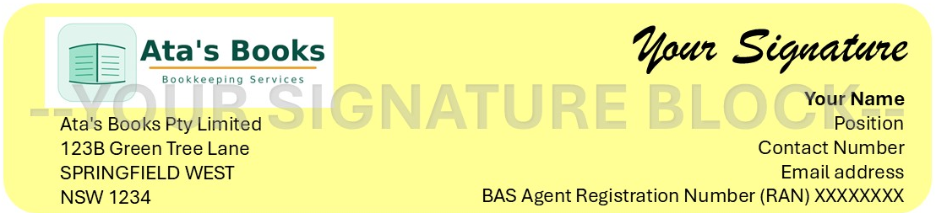

Client Declaration and Authorisation
I declare that the information provided to them for the preparation of the Taxable Payments Annual Report is true and correct and that to the best of my knowledge, all relevant information has been provided to them as my BAS agent.
We will retain valid tax invoices and ABNs for all amounts paid to the relevant contractors. A copy of the relevant reports has been reviewed and approved by me.
I declare that this authority is only for a period of no more than 12 months, at which time it will be reviewed and agreed upon.

By signing below, I am declaring both that I agree and that I am authorised to make this decision.

